Topic : Function Overloading
Q1. What is the output of this program?
#include <iostream>
using namespace std;
void print(int i)
{
cout << i;
}
void print(double f)
{
cout << f;
}
int main(void)
{
print(5);
print(500.263);
return 0;
}
Q2. What do you understand by function overloading? Give example.
Q3. Write a c++ program that uses a function to check a given number is divisible by another number or not.
Q4. What is the output of this program?
#include <iostream>
using namespace std;
int Add(int X, int Y, int Z)
{
return X + Y;
}
double Add(double X, double Y, double Z)
{
return X + Y;
}
int main()
{
cout << Add(5, 6);
cout << Add(5.5, 6.6);
return 0;
}
Q5. What is the output of the following program?
#include <iostream>
using namespace std;
int operate (int a, int b)
{
return (a * b);
}
float operate (float a, float b)
{
return (a / b);
}
int main()
{
int x = 5, y = 2;
float n = 5.0, m = 2.0;
cout << operate(x, y) <<"\t";
cout << operate (n, m);
return 0;
}
Q6. Write a C++ program that uses area() for the calculation of area of a triangle or a square.
Q7. What is friend function.
Q8. How do you implement inline function?
Q9. C++ does not allow arguments other than the last to be given default values. Justify this statement.
Q10. How is matching done in case of overloaded functions?
Q11. How would you compare default arguments and a function overloading?
Q12. Illustrate the concept of function overloading with the help of an example.
Q13. How does the compiler interpret more than one definitions having same name.
Q14. Write a function that receives two numbers as an argument and display all prime numbers between these two numbers. Call this function from main( ).
Q15. Write a program using function which accept two integers as an argument and return its sum. Call this function from main( ) and print the results in main( )
Q16. Write the output of the following program :
#include <iostream>
using namespace std;

void X(int &A, int &B)
{
A = A + B;
B = A - B;
A = A - B;
}

int main()
{
int a = 4, b = 18;
X(a,b);
cout << a << ", " << b;

return 0;
}
Q17. Write the output of the following program:
#include <iostream>
using namespace std;

int func(int &x, int y = 10)
{
if (x % y == 0)
return ++x;
else
return y--;
}

int main()
{
int p = 20, q = 23;

q = func(p, q);
cout << p << " " << " " << q << endl;

p = func (q);
cout << p << " " << " " << q << endl;

q = func (p);
cout << p << " " << " " << q << endl;

return 0;
}
Q18. Raising a number to a power p is the same as multiplying n by itself p times. Write a function called power that takes two arguments, a double value for n and an int value for p, and return the result as double value. Use default argument of 2 for p, so that if this argument is omitted the number will be squared. Write the main function that gets value from the user to test power function.

Topic : Classes and Objects
Q1. What is the relationship of a class and an object?
Q2. What does an object transfer to another?
Q3. Define static data member.
Q4. What is wrong with the following:
{
Int a,b;
public:
void read();
}
Q5. Which is the parameter that is added to every non-static member function when it is called?
Q6. Is encapsulation a security technique?
Q7. What are the advantages and disadvantages of inline function?
Q8.
(a) How is memory allocated to a class and its objects?
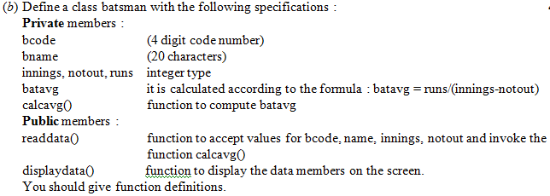
Q9. What’s the deal with inline functions?
Q10. Describe the two ways of defining the member functions in the class.
Q11. What’s wrong with this?
Class c { public: int x =0;};
Q12. How do you tell the compiler to make a member function online?

Q13. How to define a class in C++?

Q14. Differentiate between class and structure.

Q15. Why size of an object of an empty class is 1 byte?

Q16. What is modifier?

Q17. Explain friend class in C++.

Q18. How do you access the static member of a class?

Q19. What is the default access level?

Q20. What is “mutable”?

Q21. Could you write a small program that will compile in C but not in C++.

Q22. How to access data member and member function in C++?

